Welcome To
Trinity Lutheran Church
Lutheran Church - Missouri Synod
A Stephen Ministry Congregation

1354 South Otsego Avenue
Gaylord, MI 49735
Church Phone: 989-732-4816

Church Email: secretary@trinitygaylord.com
www.trinitygaylord.com

Office Hours:
Monday through Friday 9am - 1pm

OUR PURPOSE

. . . is to LOVE GOD, LOVE OTHERS AND SERVE THE WORLD by worshiping the Lord Jesus, bringing our members into Christ-like maturity, and equipping them through Word and Sacrament for their mission and ministry. We go heart to heart into the world with Jesus, sharing His love, caring for one another, praying, and bringing the lost into a relationship with Christ, by the working of the Holy Spirit.

May 7, 2023
Fifth Sunday of Easter
Preacher: Rev. Ken Bernthal

ABOUT OUR WORSHIP

We welcome all who gather here today! We are blessed to celebrate together the mercy, grace and love we have from God through the death and resurrection of our Lord Jesus Christ.

Children: Families with children are very welcome here. Having children in church is important so they can begin to learn about their faith in Jesus, and it’s good for the whole congregation to see. Please feel comfortable keeping “squirmy” kids in the service. This is where they belong, too!

Pew cards: Guest and Members, please fill out a Guest/Member card located in the pew rack. The card can be placed in the offering plates at the back of the church.

If standing is difficult feel free to remain seated during any portion of the service. Please let an Elder or Usher know if you need communion in your pew seat.

About our celebration of Holy Communion: We celebrate the Lord’s Supper in the confession and glad confidence that, as he says, our Lord gives into our mouths not only bread and wine but his very body and blood to eat and drink for the forgiveness of sins and to strengthen our union with him and with one another. Our Lord invites to his table those who trust his words, repent of all sin and set aside any refusal to forgive and love as he forgives and loves us, that they may show forth his death until he comes.

Because those who eat and drink our Lord’s body and blood contrary to that which is stated above do so to their great harm, and because Holy Communion is a confession of the faith which is confessed at this altar. Anyone who is not yet instructed, in doubt, or who hold a confession differing from that of the Lutheran Church Missouri Synod, and yet desire to receive the sacrament, are asked to first speak with Pastor. Those not communing are still invited to come forward for a blessing from Pastor, and you may indicate this by crossing your arms over your chest.

Greeting
P Peace be with you.
C And also with you

Divine Service - Setting Four LSB 203

Opening Hymn

644 The Church’s One Foundation
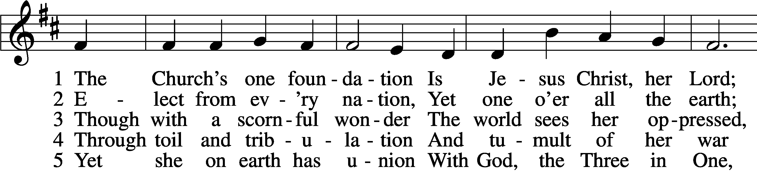
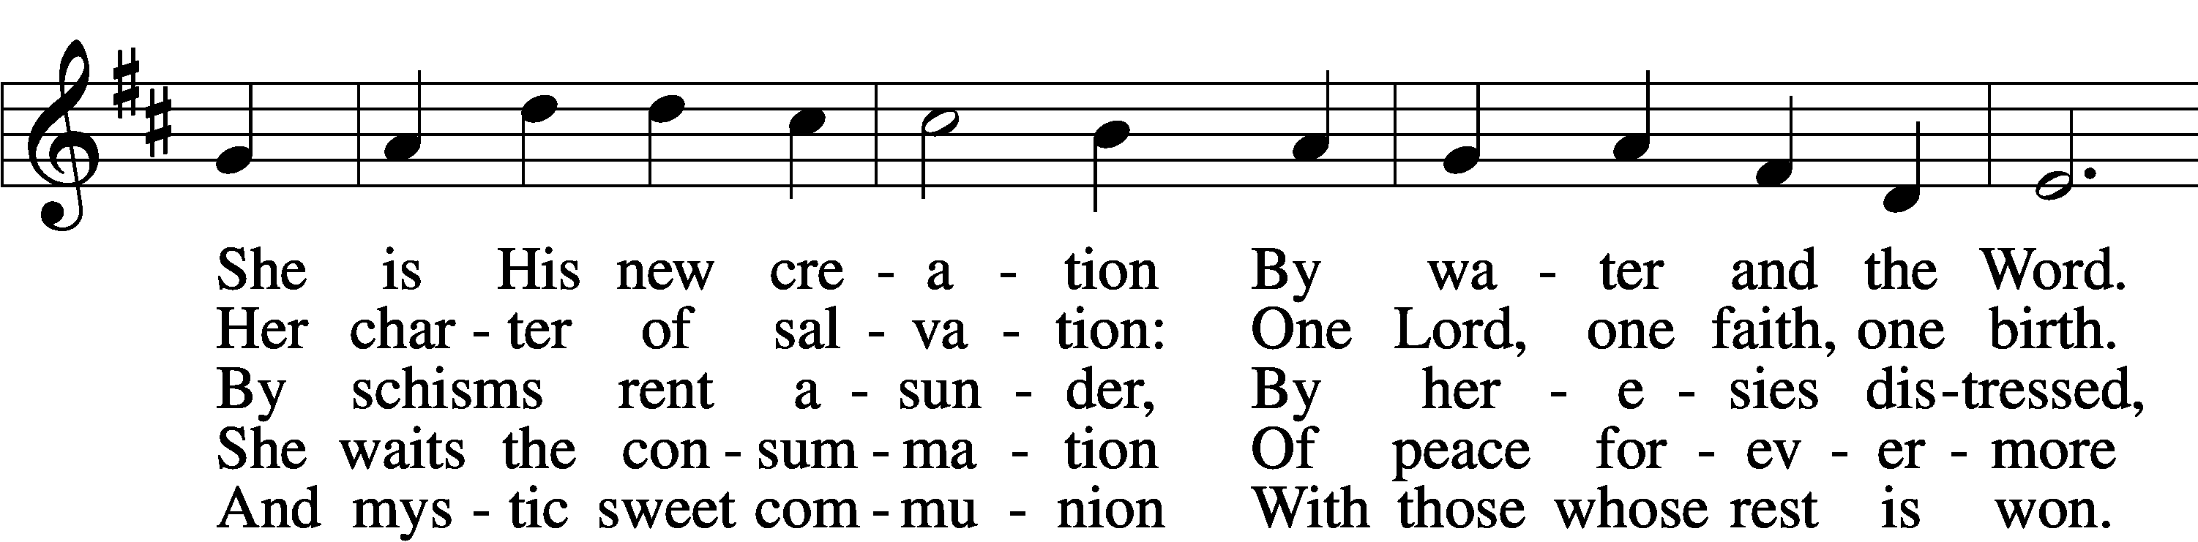
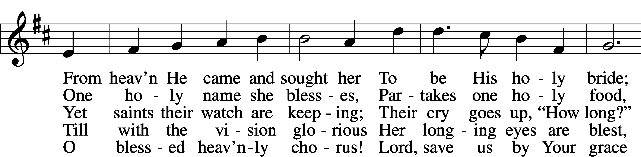
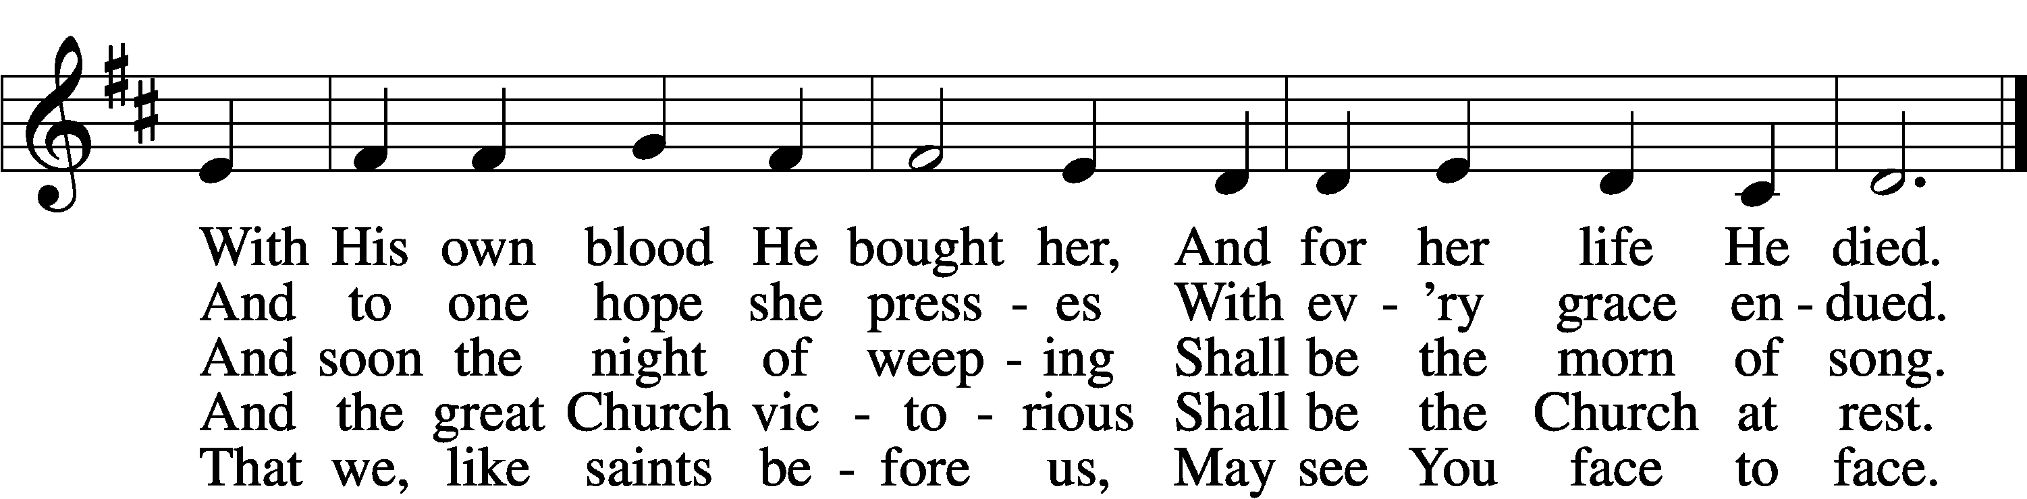
Stand

Confession and Absolution

The sign of the cross may be made by all in remembrance of their Baptism.

Invocation
P In the name of the Father and of the T Son and of the Holy Spirit.
C Amen.

Exhortation LSB 203
P Our help is in the name of the Lord,
C who made heaven and earth.

P If You, O Lord, kept a record of sins, O Lord, who could stand?
C But with You there is forgiveness; therefore You are feared.

P Since we are gathered to hear God’s Word, call upon Him in prayer and praise, and receive the body and blood of our Lord Jesus Christ in the fellowship of this altar, let us first consider our unworthiness and confess before God and one another that we have sinned in thought, word, and deed, and that we cannot free ourselves from our sinful condition. Together as His people let us take refuge in the infinite mercy of God, our heavenly Father, seeking His grace for the sake of Christ, and saying: God, be merciful to me, a sinner.

Confession of Sins LSB 203
C Almighty God, have mercy upon us, forgive us our sins, and lead us to everlasting life. Amen.

Prayer for Forgiveness
P Almighty God, merciful Father, in Holy Baptism You declared us to be Your children and gathered us into Your one, holy Church, in which You daily and richly forgive us our sins and grant us new life through Your Spirit. Be in our midst, enliven our faith, and graciously receive our prayer and praise; through Your Son, Jesus Christ, our Lord.
C Amen.

Service of the Word

Introit
P Praise the Lord! Sing to the Lord a new song,
C his praise in the assembly of the godly!
P I will extol you, O Lord, for you have drawn me up
C and have not let my foes rejoice over me.
P O Lord my God, I cried to you for help,
C and you have healed me.
P O Lord, you have brought up my soul from Sheol;
C you restored me to life from among those who go down to the pit.
P Sing praises to the Lord, O you his saints,
C and give thanks to his holy name.
P For his anger is but for a moment, and his favor is for a lifetime.
C Weeping may tarry for the night, but joy comes with the morning.

A Glory be to the Father and to the Son
and to the Holy Spirit;
as it was in the beginning,
is now, and will be forever. Amen.

P Praise the Lord! Sing to the Lord a new song,
C his praise in the assembly of the godly!

Kyrie LSB 204
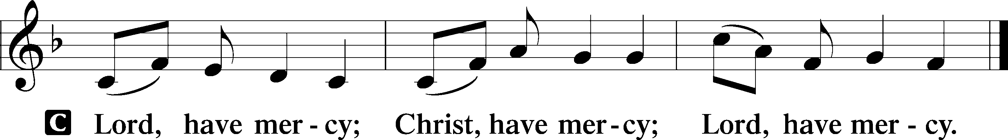

Gloria in Excelsis LSB 204
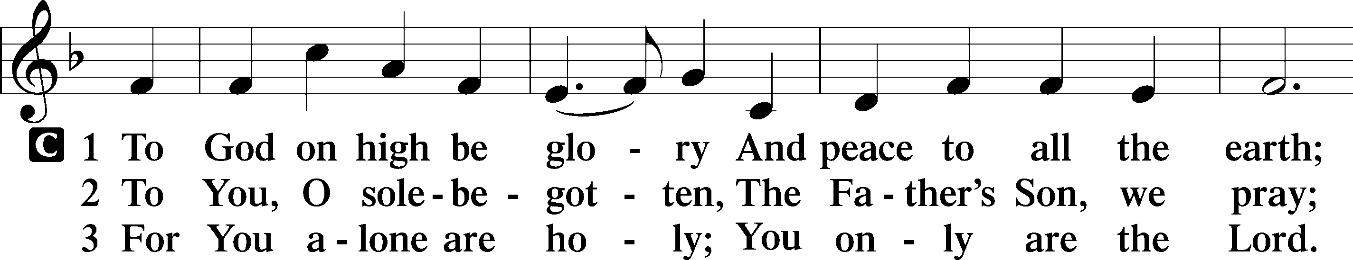
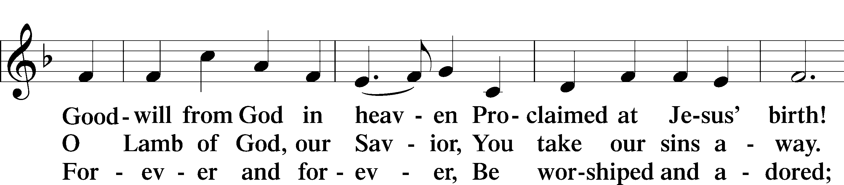
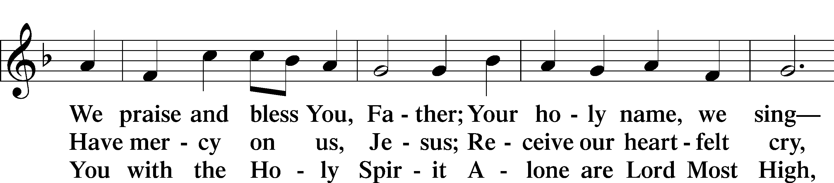
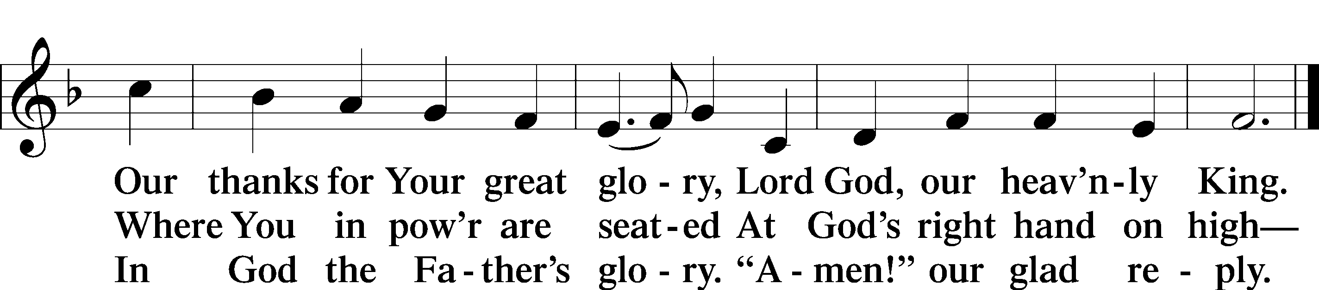

Salutation and Collect of the Day
P The Lord be with you.
C And also with you.

P Let us pray.
O God, You make the minds of Your faithful to be of one will. Grant that we may love what You have commanded and desire what You promise, that among the many changes of this world our hearts may be fixed where true joys are found; through Jesus Christ, Your Son, our Lord, who lives and reigns with You and the Holy Spirit, one God, now and forever.

C Amen.

Sit

Old Testament Acts 6:1–9; 7:2a, 51–60
1Now in these days when the disciples were increasing in number, a complaint by the Hellenists arose against the Hebrews because their widows were being neglected in the daily distribution. 2And the twelve summoned the full number of the disciples and said, “It is not right that we should give up preaching the word of God to serve tables. 3Therefore, brothers, pick out from among you seven men of good repute, full of the Spirit and of wisdom, whom we will appoint to this duty. 4But we will devote ourselves to prayer and to the ministry of the word.” 5And what they said pleased the whole gathering, and they chose Stephen, a man full of faith and of the Holy Spirit, and Philip, and Prochorus, and Nicanor, and Timon, and Parmenas, and Nicolaus, a proselyte of Antioch. 6These they set before the apostles, and they prayed and laid their hands on them.
7And the word of God continued to increase, and the number of the disciples multiplied greatly in Jerusalem, and a great many of the priests became obedient to the faith.
8And Stephen, full of grace and power, was doing great wonders and signs among the people. 9Then some of those who belonged to the synagogue of the Freedmen (as it was called), and of the Cyrenians, and of the Alexandrians, and of those from Cilicia and Asia, rose up and disputed with Stephen. . . .
7:2aAnd Stephen said:
“Brothers and fathers, hear me. . . .
51You stiff-necked people, uncircumcised in heart and ears, you always resist the Holy Spirit. As your fathers did, so do you. 52Which of the prophets did not your fathers persecute? And they killed those who announced beforehand the coming of the Righteous One, whom you have now betrayed and murdered, 53you who received the law as delivered by angels and did not keep it.”
54Now when they heard these things they were enraged, and they ground their teeth at him. 55But he, full of the Holy Spirit, gazed into heaven and saw the glory of God, and Jesus standing at the right hand of God. 56And he said, “Behold, I see the heavens opened, and the Son of Man standing at the right hand of God.” 57But they cried out with a loud voice and stopped their ears and rushed together at him. 58Then they cast him out of the city and stoned him. And the witnesses laid down their garments at the feet of a young man named Saul. 59And as they were stoning Stephen, he called out, “Lord Jesus, receive my spirit.” 60And falling to his knees he cried out with a loud voice, “Lord, do not hold this sin against them.” And when he had said this, he fell asleep.

P This is the Word of the Lord.
C Thanks be to God.

Epistle 1 Peter 2:2–10
2Like newborn infants, long for the pure spiritual milk, that by it you may grow up to salvation— 3if indeed you have tasted that the Lord is good.
4As you come to him, a living stone rejected by men but in the sight of God chosen and precious, 5you yourselves like living stones are being built up as a spiritual house, to be a holy priesthood, to offer spiritual sacrifices acceptable to God through Jesus Christ. 6For it stands in Scripture:
“Behold, I am laying in Zion a stone,
a cornerstone chosen and precious,
and whoever believes in him will not be put to shame.”
7So the honor is for you who believe, but for those who do not believe,
“The stone that the builders rejected
has become the cornerstone,”
8and
“A stone of stumbling,
and a rock of offense.”
They stumble because they disobey the word, as they were destined to do.
9But you are a chosen race, a royal priesthood, a holy nation, a people for his own possession, that you may proclaim the excellencies of him who called you out of darkness into his marvelous light. 10Once you were not a people, but now you are God’s people; once you had not received mercy, but now you have received mercy.

P This is the Word of the Lord.
C Thanks be to God.

Stand

Alleluia and Verse

Alleluia LSB 205
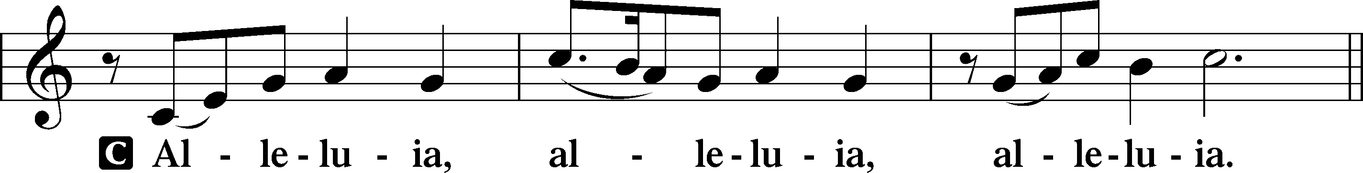

Verse LSB 205
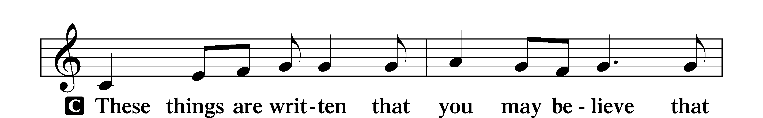
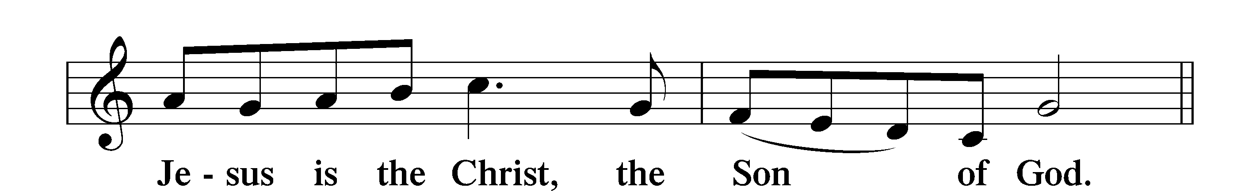

Alleluia LSB 205
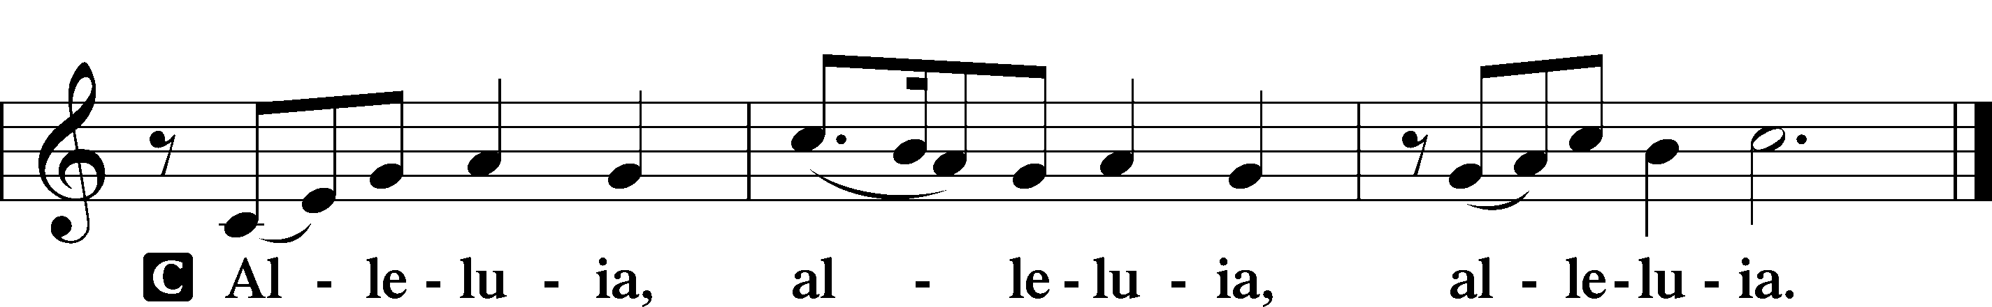

Holy Gospel John 14:1–14
P The Holy Gospel according to St. John, the fourteenth chapter.
C Glory to You, O Lord.

1[Jesus said:] “Let not your hearts be troubled. Believe in God; believe also in me. 2In my Father’s house are many rooms. If it were not so, would I have told you that I go to prepare a place for you? 3And if I go and prepare a place for you, I will come again and will take you to myself, that where I am you may be also. 4And you know the way to where I am going.” 5Thomas said to him, “Lord, we do not know where you are going. How can we know the way?” 6Jesus said to him, “I am the way, and the truth, and the life. No one comes to the Father except through me. 7If you had known me, you would have known my Father also. From now on you do know him and have seen him.”
8Philip said to him, “Lord, show us the Father, and it is enough for us.” 9Jesus said to him, “Have I been with you so long, and you still do not know me, Philip? Whoever has seen me has seen the Father. How can you say, ‘Show us the Father’? 10Do you not believe that I am in the Father and the Father is in me? The words that I say to you I do not speak on my own authority, but the Father who dwells in me does his works. 11Believe me that I am in the Father and the Father is in me, or else believe on account of the works themselves.
12“Truly, truly, I say to you, whoever believes in me will also do the works that I do; and greater works than these will he do, because I am going to the Father. 13Whatever you ask in my name, this I will do, that the Father may be glorified in the Son. 14If you ask me anything in my name, I will do it.”

P This is the Gospel of the Lord.
C Praise to You, O Christ.

Nicene Creed
C I believe in one God,
the Father Almighty,
maker of heaven and earth
and of all things visible and invisible.

And in one Lord Jesus Christ,
the only-begotten Son of God,
begotten of His Father before all worlds,
God of God, Light of Light,
very God of very God,
begotten, not made,
being of one substance with the Father,
by whom all things were made;
who for us men and for our salvation came down from heaven
and was incarnate by the Holy Spirit of the virgin Mary
and was made man;
and was crucified also for us under Pontius Pilate.
He suffered and was buried.
And the third day He rose again according to the Scriptures
and ascended into heaven
and sits at the right hand of the Father.
And He will come again with glory to judge both the living and the dead,
whose kingdom will have no end.

And I believe in the Holy Spirit,
the Lord and giver of life,
who proceeds from the Father and the Son,
who with the Father and the Son together is worshiped and glorified,
who spoke by the prophets.
And I believe in one holy Christian and apostolic Church,
I acknowledge one Baptism for the remission of sins,
and I look for the resurrection of the dead
and the life T of the world to come. Amen.

Sit

Children's Talk

Sermon Hymn

648 Glorious Things of You Are Spoken
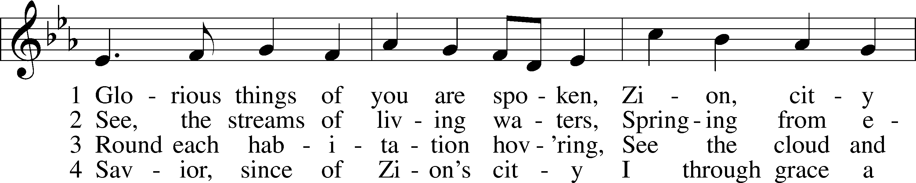
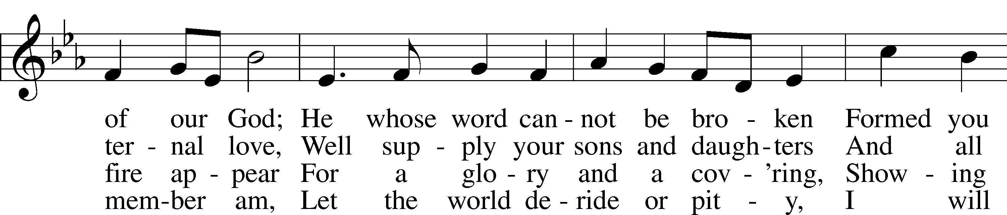
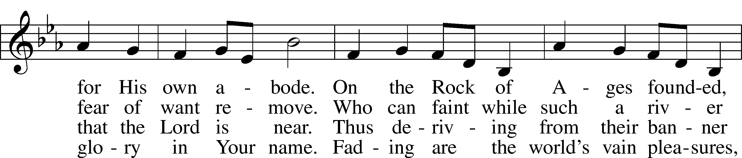
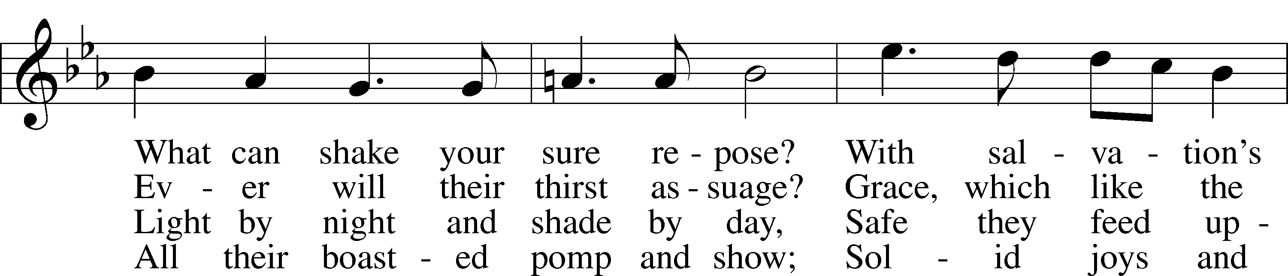
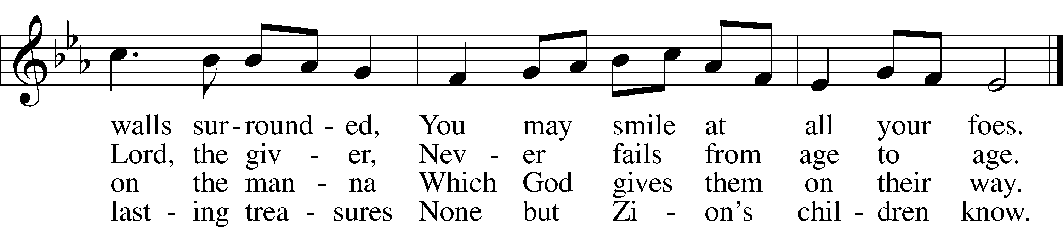

Sermon

Stand

Prayer of the Church

Prayer Response
After each segment:
P Lord, in Your mercy,
C hear our prayer.

After prayers:
P In the name of Jesus we pray.
C Amen.

Service of the Sacrament

Preface 208
P The Lord be with you.
C And also with you.

P Lift up your hearts.
C We lift them to the Lord.

P Let us give thanks to the Lord our God.
C It is right to give Him thanks and praise.

P It is truly good, right, and salutary that we should at all times and in all places give thanks to You, O Lord, holy Father, almighty and everlasting God, for the countless blessings You so freely bestow on us and all creation. Above all, we give thanks for Your boundless love shown to us when You sent Your only-begotten Son, Jesus Christ, into our flesh and laid on Him our sin, giving Him into death that we might not die eternally. Because He is now risen from the dead and lives and reigns to all eternity, all who believe in Him will overcome sin and death and will rise again to new life. Therefore with angels and archangels and with all the company of heaven we laud and magnify Your glorious name, evermore praising You and singing:

Sanctus LSB 208
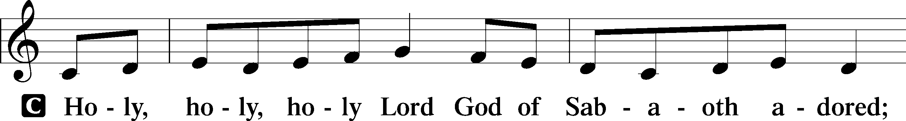
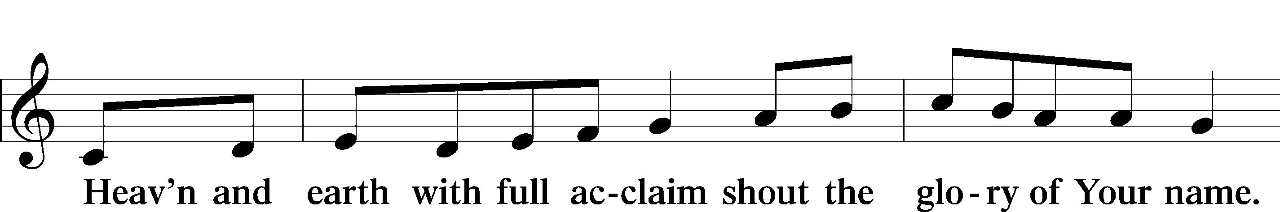
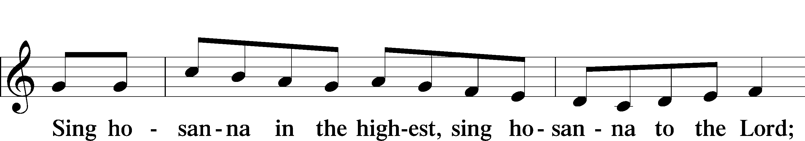
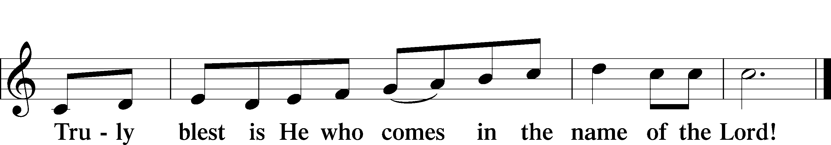

Prayer of Thanksgiving
P Blessed are You, O Lord our God, king of all creation, for You have had mercy on us and given Your only-begotten Son that whoever believes in Him should not perish but have eternal life.

For Christ, our Passover Lamb, has been sacrificed. By His death, He has redeemed us from bondage to sin and death, and by His resurrection, He has delivered us into new life in Him.

Grant us to keep the Feast in sincerity and truth, faithfully eating His body given into death and drinking His life’s blood poured out for our salvation until we pass through death to the promised land of life eternal.

Hear us as we pray in His name and as He has taught us:

Lord’s Prayer
C Our Father who art in heaven,
hallowed be Thy name,
Thy kingdom come,
Thy will be done on earth
as it is in heaven;
give us this day our daily bread;
and forgive us our trespasses
as we forgive those
who trespass against us;
and lead us not into temptation,
but deliver us from evil.
For Thine is the kingdom
and the power and the glory
forever and ever. Amen.

The Words of Our Lord
P Our Lord Jesus Christ, on the night when He was betrayed, took bread, and when He had given thanks, He broke it and gave it to the disciples and said: “Take, eat; this is My T body, which is given for you. This do in remembrance of Me.”

In the same way also He took the cup after supper, and when He had given thanks, He gave it to them, saying: “Drink of it, all of you; this cup is the new testament in My T blood, which is shed for you for the forgiveness of sins. This do, as often as you drink it, in remembrance of Me.”

Pax Domini
P The peace of the Lord be with you always.
C Amen.

Agnus Dei LSB 210
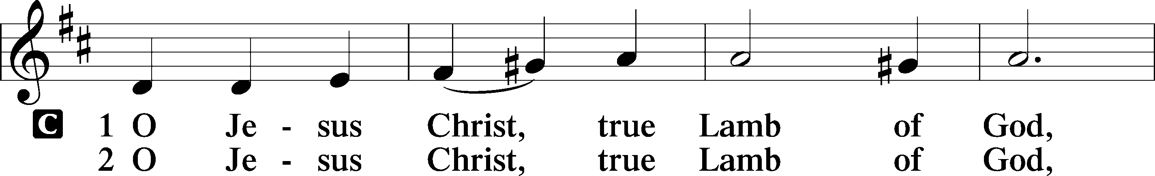
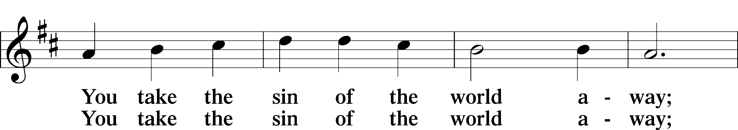
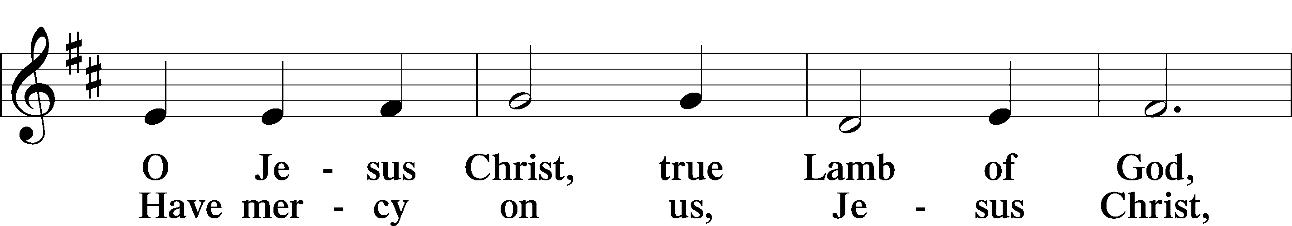
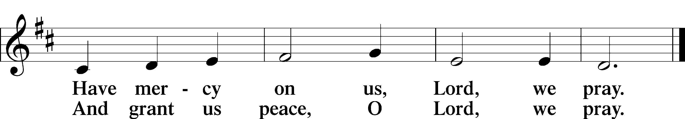

Sit

Distribution Hymns

610 Lord Jesus, Think on Me
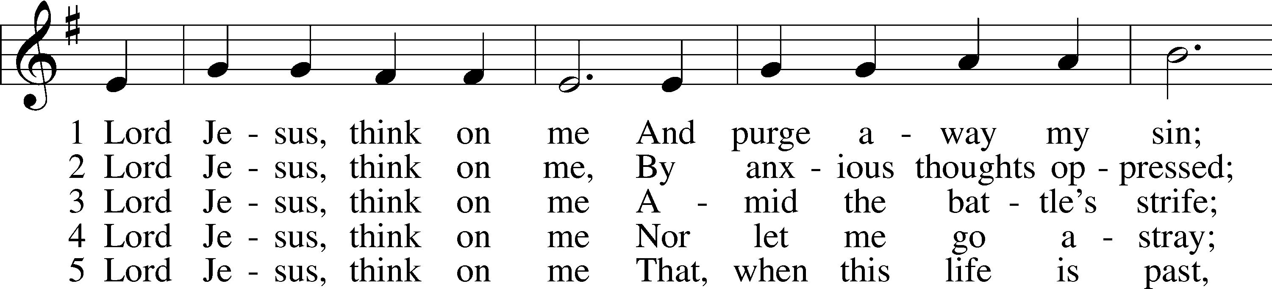
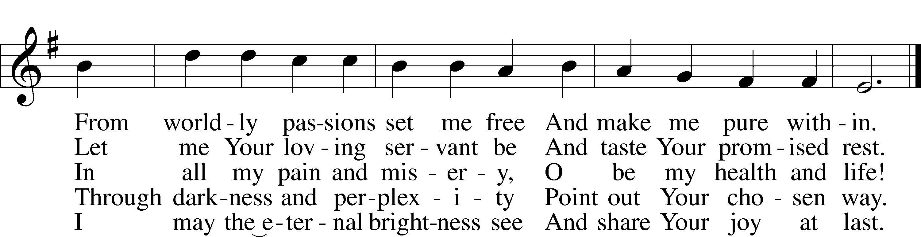

543 What Wondrous Love Is This
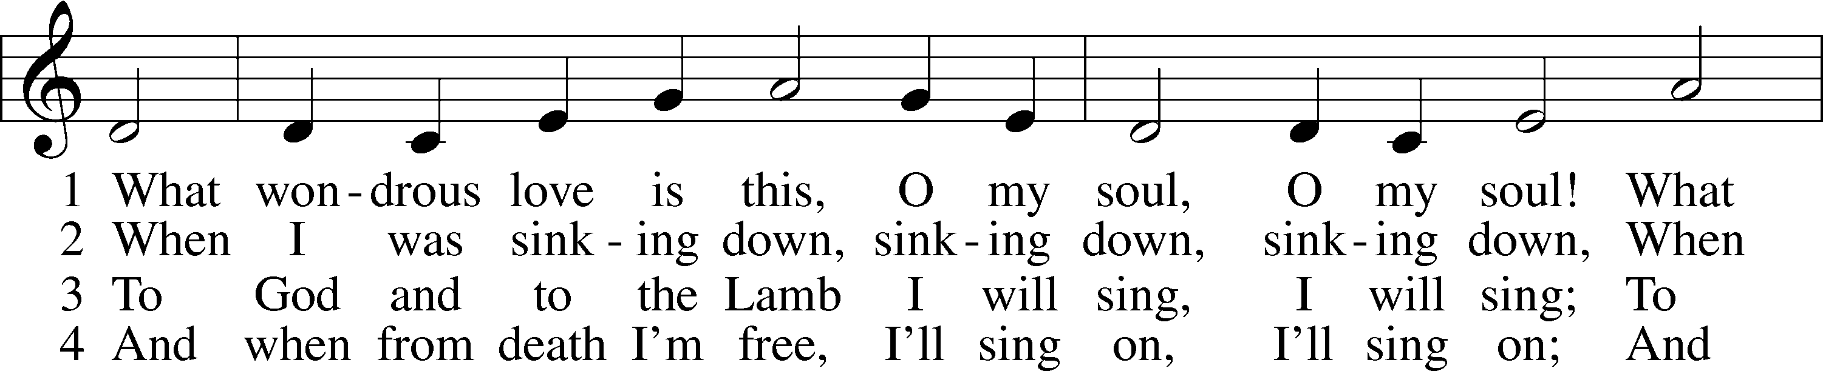
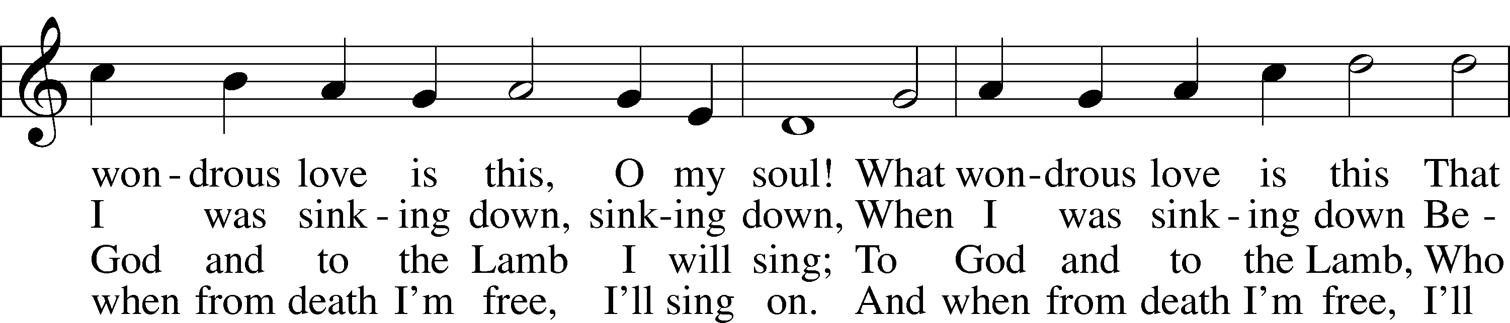
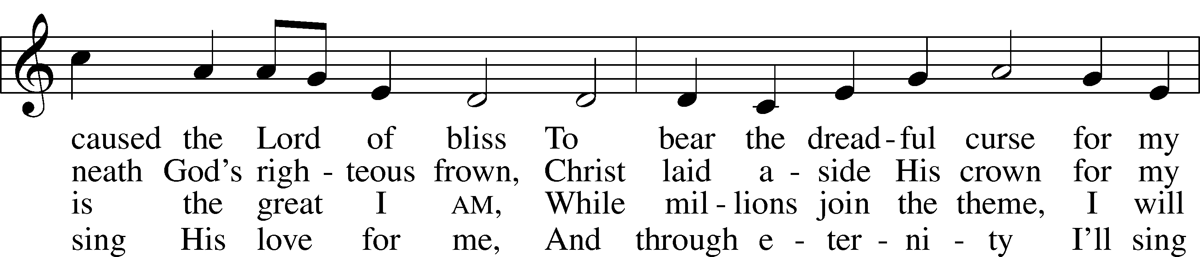
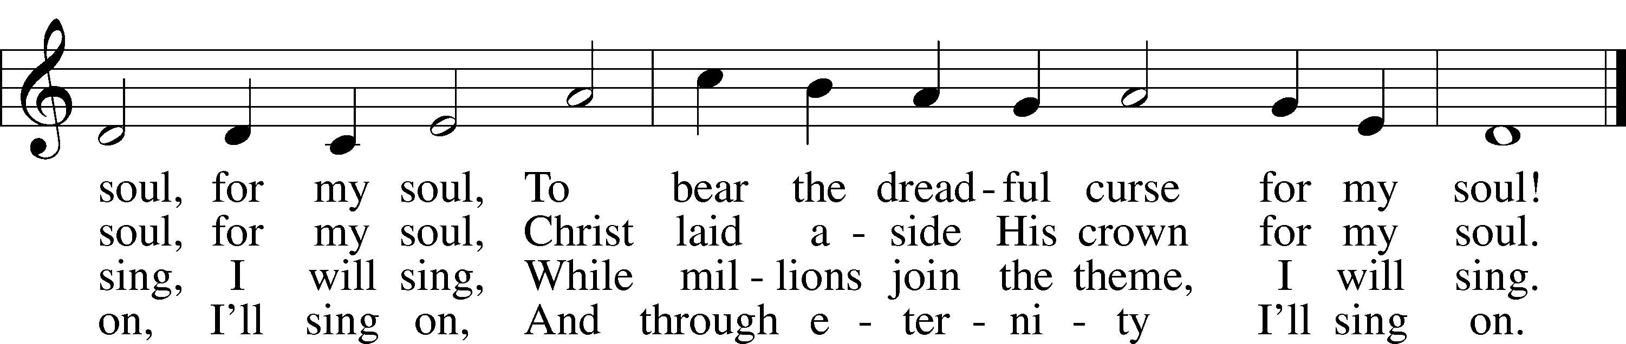

Stand

Nunc Dimittis LSB 211
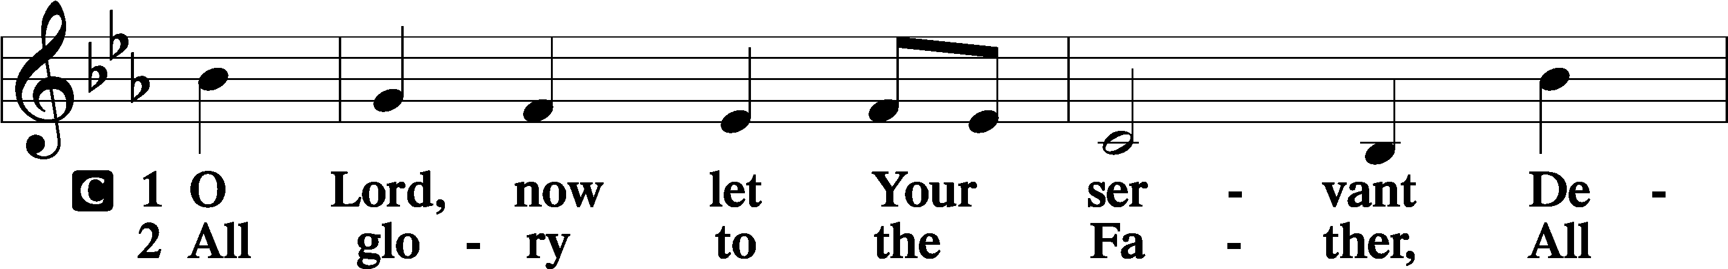
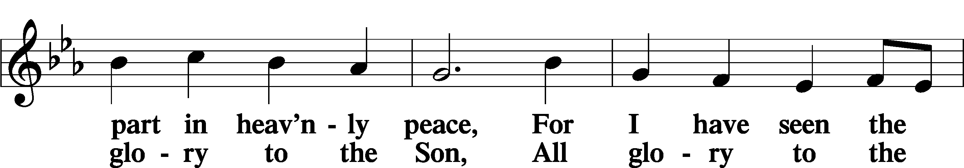
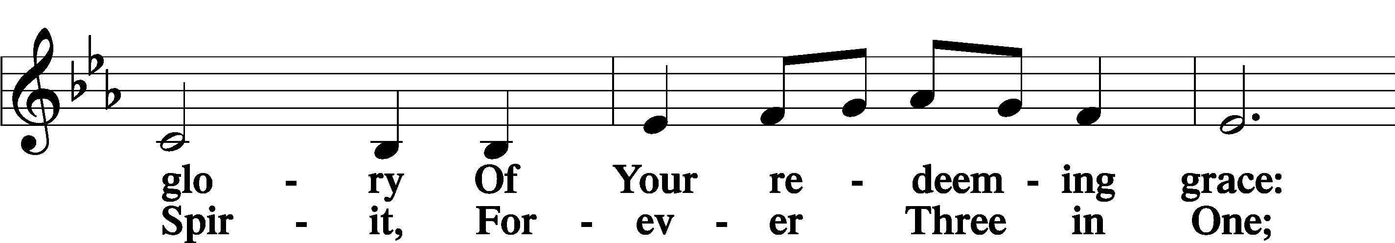
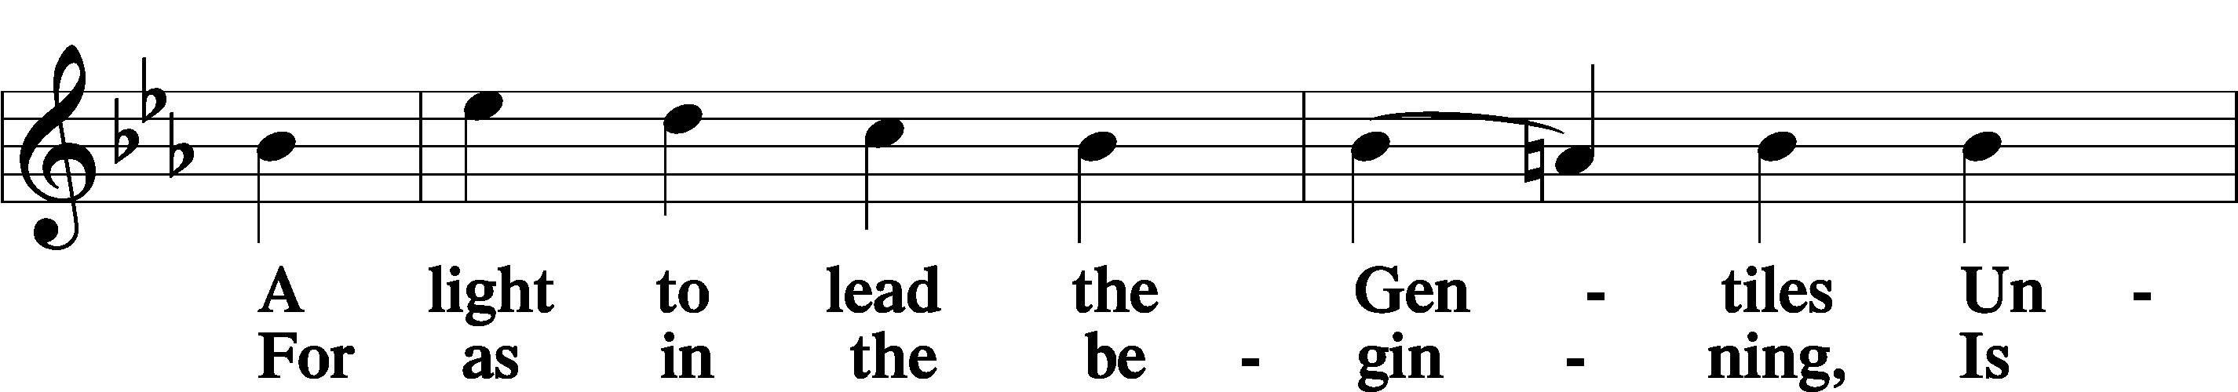
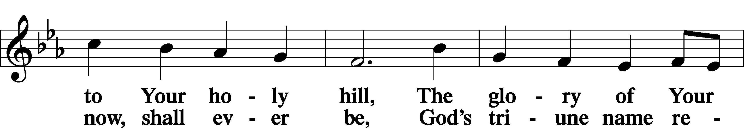
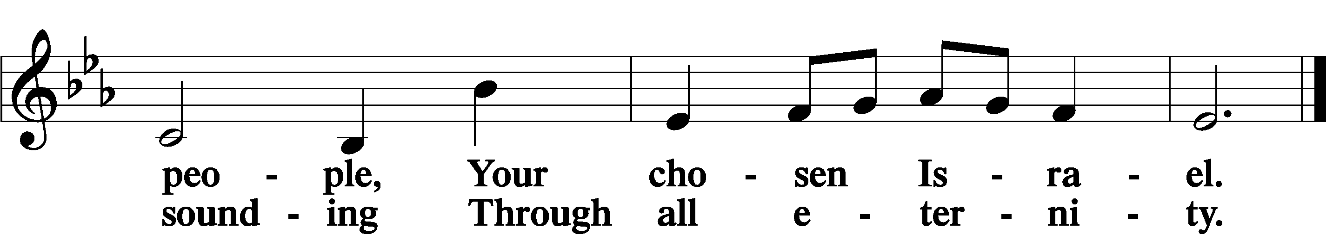

Post-Communion Collect
P Let us pray.

We give thanks to You, almighty God, that You have refreshed us through this salutary gift, and we implore You that of Your mercy You would strengthen us through the same in faith toward You and in fervent love toward one another; through Jesus Christ, Your Son, our Lord, who lives and reigns with You and the Holy Spirit, one God, now and forever.
C Amen.

Benedicamus 212
P Let us bless the Lord.
C Thanks be to God.

Benediction
P The Lord bless you and keep you.
The Lord make His face shine on you and be gracious to you.
The Lord look upon you with favor and T give you peace.
C Amen.

643 Sent Forth by God’s Blessing
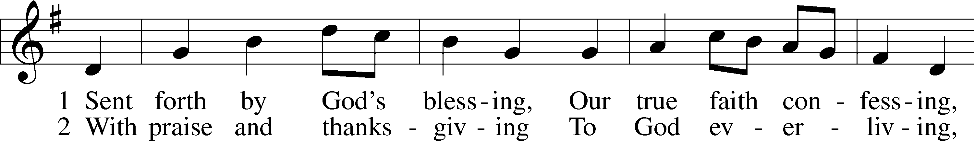
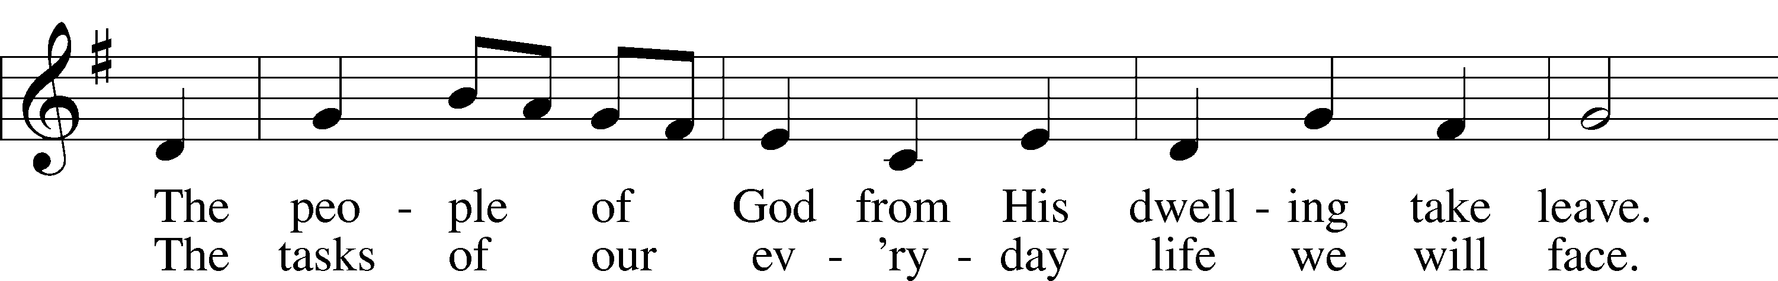
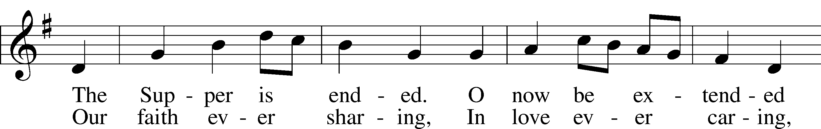
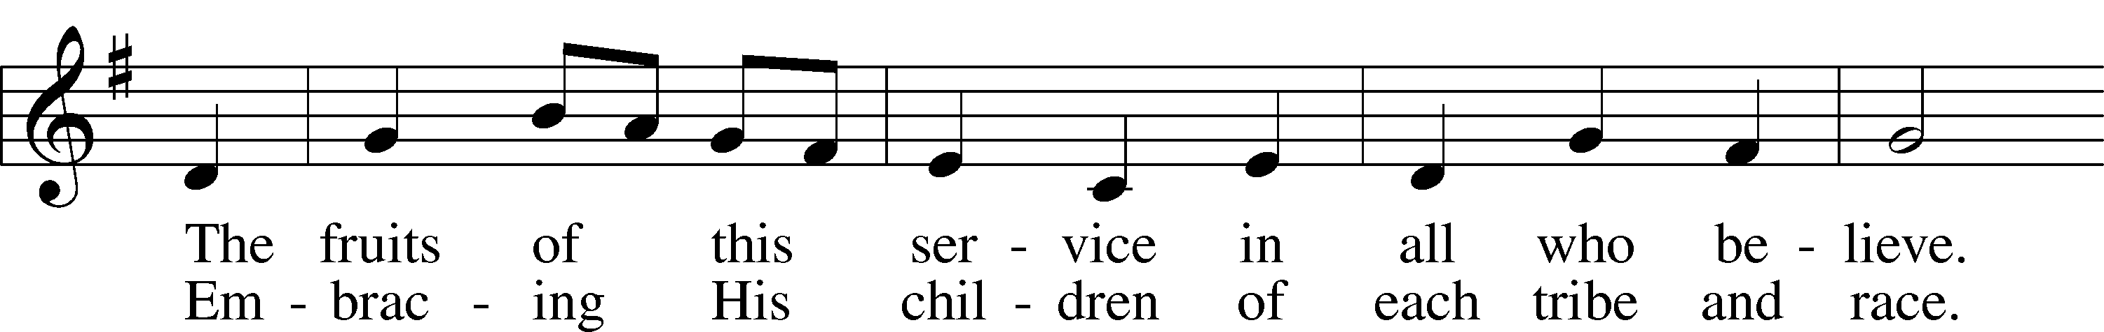
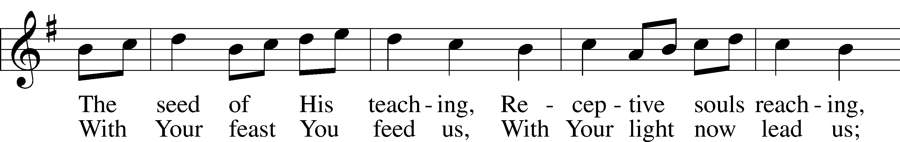
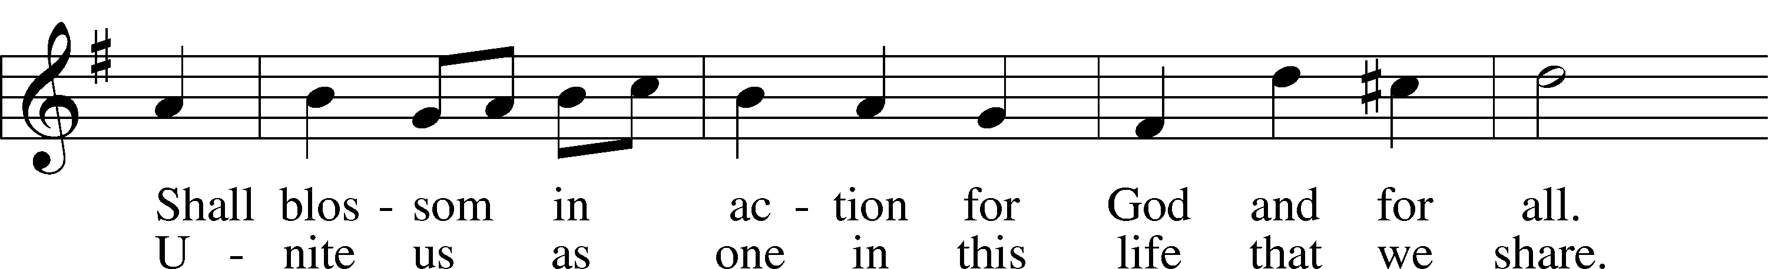
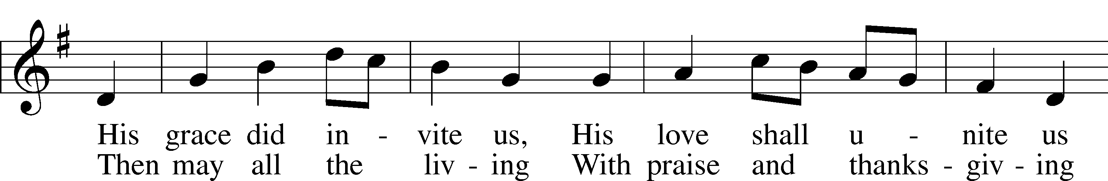
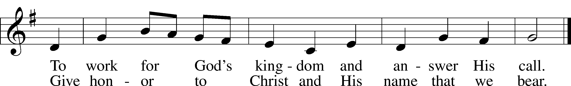

Closing Statement
P We go to live for Jesus.
C We go to share His love.

Acknowledgments
Unless otherwise indicated, Scripture quotations are from the ESV® Bible (The Holy Bible, English Standard Version®), copyright 2001 by Crossway, a publishing ministry of Good News Publishers. Used by permission. All rights reserved. Created by Lutheran Service Builder. Music reproduced in this service is used with permission through: CCLI License No.1776588 and CPH – LSB Service Builder.

